Abbott is an associate member of the Early Detection Research Network. Testing and analysis will be performed within six weeks of receipt of the Reference Set.

Clinical Relationship
The goal of the sample set’s use is to help develop an automated Pro–Surfactant Protein B (ProSFTPB) assay to aid in the early detection of lung cancer. The likely intended-use population for this assay, and panel it is planned to be a part of, is made up of “at-risk” individuals with factors that increase their potential for developing lung cancer and have indeterminate pulmonary nodules (IPN). This severely limits the availability of specimens for use and therefore increases both the burden of acquiring them and value associated with patient information. This sample set directly addresses the patient population needs and contains vital patient information to ensure assay performance metrics are reflective of its intended use case. The later discussed four‑marker panel (4MP) algorithm and LungSpotTM test developed first by M.D. Anderson Cancer center contains three commercialized IVD assays (CEA, CA 125, and CYFRA 21-1) which Abbott currently offers automated diagnostic tests for. This only requires the development of a ProSFTPB assay. This sample will be tested on all four Abbott assays to determine the clinical utility of the algorithm panel. Together, this biomarker panel is intended to support classification of indeterminate pulmonary nodules (IPN) in at-risk populations.

Background and Significance
For both men and women, lung and bronchial cancers are the second most prevalent newly diagnosed cancers year over year. For each sex, this class accounts for 14% of new cases with only prostate and breast cancer at 29% being more common for men and women respectively. In 2012, lung cancer accounted for approximately 26% of all female cancer deaths and 29% of all male cancer deaths which is the highest of all cancer types (R. Siegel et al., 2012; Sin et al., 2013). There is a lack of commercialized diagnostic assays suitable for the early detection of lung cancer and it is currently difficult to accurately diagnose due to radiographic screenings and biopsies being the only options. Nodules identified by a CT scan must be biopsied to identify their condition and only about 20% of those biopsied are identified as malignant (X. J. Li et al., 2013). Several sources have identified ProSFTPB as a promising potential biomarker to help diagnoses in non–small-cell lung cancer patients to provide a supporting alternative to these isolated methods (Fahrmann et al., 2022; Guida et al., 2018; X. J. Li et al., 2013; Luo et al., 2023; Ostrin et al., 2021; Sin et al., 2013; Taguchi et al., 2013; Trinkmann et al., 2014). Abbott’s Alinity i ProSFTPB RUO assay is a chemiluminescent microparticle immunoassay (CMIA) that uses a sandwich style capture and detection method.

Preliminary Data and Methods
MD Anderson Cancer Center (Houston, TX) developed a sandwich ELISA employing mouse monoclonal antibodies directed against the N‑terminal region of Pro–Surfactant Protein B (ProSFTPB). This assay was applied to plasma and serum samples from patients with non–small cell lung cancer (NSCLC) and from matched control subjects selected for age, sex, and additional demographic variables. The study demonstrated that circulating ProSFTPB concentrations are significantly associated with the presence of lung cancer.
ProSFTPB, when combined with the established serum/plasma biomarkers CEA, CA125, and CYFRA21‑1, constitutes the four‑marker panel (4MP) algorithm. The algorithm is calculated as follows (Ehsan Irajizad, et al:
4MP Score = [( 0.4730*log(CA125) + 0.6531*log(CEA) + 0.2613*log(CYFRA) + 0.9238*log(ProSFTPB)]
Receiver operating characteristic (ROC) analyses demonstrated that inclusion of ProSFTPB substantially improves diagnostic performance, increasing the area under the curve (AUC) from 0.669 (without ProSFTPB) to 0.741 in the evaluated study population (Sin, Don D., et al.). (See Figure 1).

Figure 1:
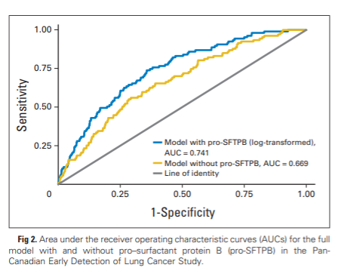

Internally at Abbott Laboratories (Abbott Park, IL), we evaluated the feasibility of integrating results from Abbott Alinity‑i immunoassays—including CEA, CA125, and CYFRA21‑1, among others—with clinical variables such as age, sex, and additional patient characteristics. The resulting predictive model, developed at Abbott Laboratories, is referred to as the Decision Tree model. Performance analysis demonstrated that the Decision Tree model achieved an AUC superior to currently available clinical prediction tools, including the Mayo Score developed by the Mayo Clinic (0.815 vs. 0.787) (Jackson, Laurel, et al.).
Findings from the MD Anderson ELISA studies suggest that incorporation of ProSFTPB into multivariable algorithms may further improve discriminative performance. In parallel, the Research Use Only (RUO) team at Abbott Laboratories developed an automated chemiluminescent immunoassay for ProSFTPB. Initial analytical and clinical evaluations showed statistically significant differences in ProSFTPB concentrations between individuals without NSCLC and those with confirmed disease (see Figure 2).
Moreover, the prototype immunoassay yielded an AUC of 0.723, which is consistent with the performance reported in prior MD Anderson evaluations (see Figure 3).

Figure 2:
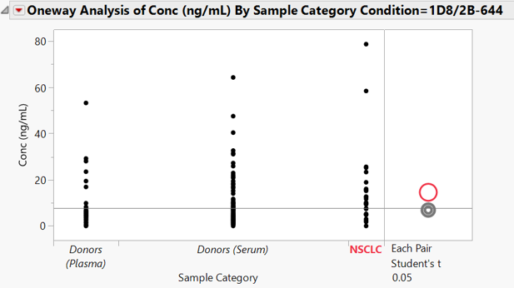
T-Test demonstrating a statistically significant between patients not diagnosed with NSCLC (donors) and those patients with a diagnosis.

Figure 3:
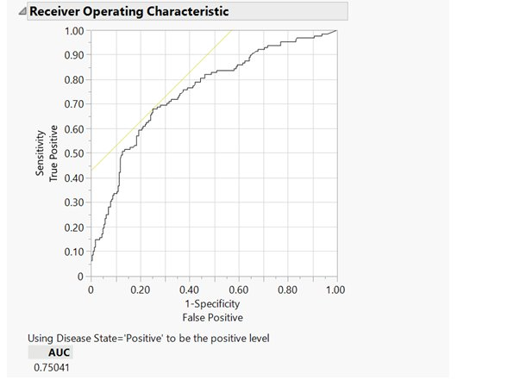
Receiver Operating Characteristic (ROC) curve demonstrating the AUC for the Abbott Laboratories ProSFTPB immunoassay is 0.75041, consistent with the AUC observed with the MD Anderson Elisa.

Data Analysis Plan
Analysis will include validation of the new ProSFTPB biomarker on the existing lung cancer algorithms discussed in Preliminary Data and Methods (4MP, Mayo Score, Decision Tree by Jackson, Laurel, et al.). The full requested reference set of approximately 270 cases and 310 controls will be sufficient to evaluate the utility of ProSFTPB in all three algorithms since the samples have balanced numbers of cases and controls, and since the number of cases is comparable to other studies in which the algorithms were developed or validated (Ehsan Irajizad, et al; Jackson, Laurel, et al.). Baseline demographic and clinical characteristics of the sample cohort will be analyzed by case/control category and malignancy status for cases. Performance of ProSFTPB will be evaluated through sensitivity and specificity analysis of each algorithm as well as the comparison of ROC curves. Sensitivity will be reported at a fixed specificity of 90% and specificity reported at fixed sensitivities of 75% and 90%, taken as the mean from 2000 bootstrapped replicates to directly compare results from Jackson, Laurel et al. Where necessary, continuous variables will be log2-transformed as features in each algorithm. Data analysis will be performed by the Clinical Statistics & Health Analytics organization of Abbott Core Diagnostics.

References:
Siegel, R., Naishadham, D., & Jemal, A. (2012). Cancer statistics, 2012. CA: A Cancer Journal for Clinicians, 62(1), 10–29. https://doi.org/10.3322/caac.20138
Li, X. J., Hayward, C., Fong, P. Y., Dominguez, M., Hunsucker, S. W., Lee, L. W., McLean, M., Law, S., Butler, H., Schirm, M., Gingras, O., Lamontagne, J., Allard, R., Chelsky, D., Price, N. D., Lam, S., Massion, P. P., Pass, H., Rom, W. N., … Kearney, P. (2013). A blood-based proteomic classifier for the molecular characterization of pulmonary nodules. Science Translational Medicine, 5(207). https://doi.org/10.1126/scitranslmed.3007013
Fahrmann, J. F., Marsh, T., Irajizad, E., Patel, N., Murage, E., Vykoukal, J., Dennison, J. B., Do, K.-A., Ostrin, ; Edwin, Spitz, M. R., Lam, S., Shete, S., Meza, R., Martin, ;, Tammemägi, C., Tammemägi, T., Feng, Z., & Hanash, S. M. (2022). Blood-Based Biomarker Panel for Personalized Lung Cancer Risk Assessment. J Clin Oncol, 0. https://doi.org/10.1200/JCO.21
Luo, H., Li, Q., Wang, R. T., Zhang, L., Zhang, W., Deng, M. S., Luo, Y. Y., Ji, X., Wen, Y., Zhou, X. R., Xu, B., Wang, D., Hu, B., Jin, H., & Xu, C. X. (2023). Downregulation of pro-surfactant protein B contributes to the recurrence of early-stage non-small cell lung cancer by activating PGK1-mediated Akt signaling. Experimental Hematology and Oncology, 12(1). https://doi.org/10.1186/s40164-023-00455-6
Ostrin, E. J., Bantis, L. E., Wilson, D. O., Patel, N., Wang, R., Kundnani, D., Adams-Haduch, J., Dennison, J. B., Fahrmann, J. F., Chiu, H. T., Gazdar, A., Feng, Z., Yuan, J. M., & Hanash, S. M. (2021). Contribution of a Blood-Based Protein Biomarker Panel to the Classification of Indeterminate Pulmonary Nodules. Journal of Thoracic Oncology, 16(2), 228–236. https://doi.org/10.1016/j.jtho.2020.09.024
Taguchi, A., Hanash, S., Rundle, A., McKeague, I. W., Tang, D., Darakjy, S., Gaziano, J. M., Sesso, H. D., & Perera, F. (2013). Circulating pro-surfactant protein b as a risk biomarker for lung cancer. Cancer Epidemiology Biomarkers and Prevention, 22(10), 1756–1761. https://doi.org/10.1158/1055-9965.EPI-13-0251
Trinkmann, F., Detzel, J., & Hutter, D. (2014). Measurement of serum proSurfactant protein-B levels Abstract Eur Respiratory Annual Congress 2013. European Respiratory Journal, 42(Suppl 57). https://doi.org/10.1183/13993003/erj.42.Suppl_57.P410
Sin, Don D, et al. “Pro–Surfactant Protein B as a Biomarker for Lung Cancer Prediction.” National Library of Medicine, vol. 31, no. 36, 20 Dec. 2013, pp. 4536–4543, https://doi.org/10.1200/jco.2013.50.6105. Accessed 21 June 2023.
Ehsan Irajizad, et al. “Biomarker Trajectory for Earlier Detection of Lung Cancer.” EBioMedicine, vol. 108, 30 Sept. 2024, pp. 105377–105377, https://doi.org/10.1016/j.ebiom.2024.105377. Accessed 15 Apr. 2025.
Jackson, Laurel, et al. “Exploratory Algorithms to Aid in Risk of Malignancy Prediction for Indeterminate Pulmonary Nodules.” Cancers, vol. 17, no. 7, 5 Apr. 2025, pp. 1231–1231, www.mdpi.com/2072-6694/17/7/1231, https://doi.org/10.3390/cancers17071231. Accessed 18 May 2025.

